# MOOC Data Week 1 Kicking Tires

AI Planning Forums / General

MOOC Data Week 1 Kicking Tires 1

Overarching Questions: 2

Basic Stats: 2

Network Analysis Techniques on forums 2

Content Analysis 3

IP Data 5

Content Based Analysis 5

At this stage the techniques are quite ‘two dimensional’, with an aim to start thinking about the questions we may ask of the data and building reusable scripts/techniques/code examples. This document has split the techniques around three questions:

1. SNA/Graph based techniques

Coming up with a process to create network data that follows the workflow of Query->Adjacency Matrix->Graph. Where can we find ties in the data set?

1. Location based

Based upon IP data. Used my own dataset.

1. Content Based

Can we analyse the text of posts to make observations about the type of post and actions of the poster

At this stage only AI planning data is used.

## Overarching Questions:

Q) Difference between forum_posts and forum_comments?

From Figure 1.1. Why so many node on their own? Comments seem like they are a different type of reply to a post.

Q) Do the Anon_user_id and forum_user_ids match up?

A) Hash table natch.

## Basic Stats:

Unique users: 29894 from Edinburgh estimation, 26775 in users table, 26547 in hash table?

26,775

Unique users in General database:

Unique users in forums database: 918 unique users in AI planning forum. This includes subscribers and ratings(?) 671 who posted?

Not sure if this query is dodgy:

select count(distinct forum_user_id) from (

select forum_user_id from forum_comments

UNION

select forum_user_id from forum_posts

UNION

select forum_user_id from forum_threads

) as users;

Unique threads: 436 (of which deleted?)

Unique posts 1846 (of which deleted?)

Unique comments: 697 (of which deleted?)

## Network Analysis Techniques on forums

fig 1.1: Forum_posts tables: All Forum users (nodes) conversing through comments on a post (edges) including deleted.

SQL: select post_id, `forum_user_id` from `forum_comments` ;

Adjacency matrix generated through R iGraph package.

## Content Analysis

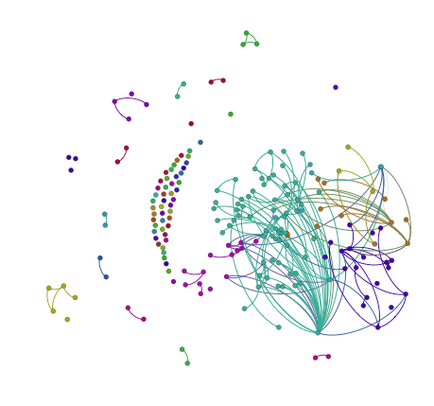

fig 1.1: All Forum users (nodes) conversing through comments on a post (edges) including deleted from forum_comments table

Fig 1.1 Remarks

Fig 1.1 Questions:

Who are the people who aren’t linked? Has nobody answered their post? How does this effect their experience?

SQL: select post_id, count(*) as cnt, `comment_text` from `forum_comments` group by `post_id` order by cnt ASC;

Seem to suggest that single posts are replies. Why don’t we have the full thread? Perhaps I misunderstand posts vs comments vs threads

Who are the people who have only talked to one or two people?

How does their interaction with the

Fig 1.2:

SQL: select thread_id, `forum_user_id` from `forum_posts` ;

Adjacency matrix generated through R iGraph package.

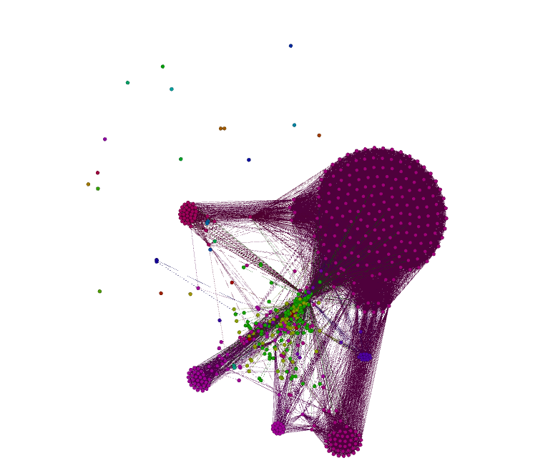

Comments:

Tutors and Pupils as same nodes.. (check access groups)

Fig 1.2:

General Table.

## IP Data

Comments:

I used my own IP lookup before realising A-M has already got a lookup table. Fortunatly we seem to have used the same data source but this needs double checking.

Only *** have data for last used IP address, does this mean they signed up, but never signed in?

Interactive File location: Aiplan_Forum/GeoMap.html

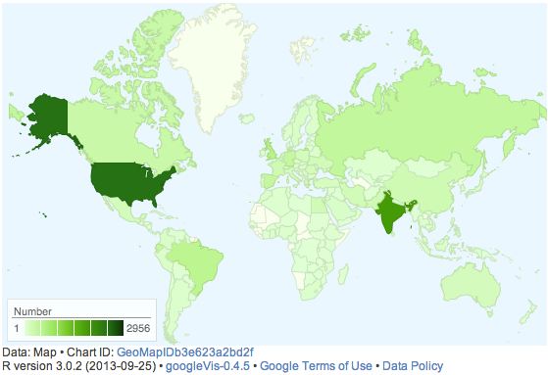

Comment

## Content Based Analysis

What do the 100% score post about?

SELECT post_text

FROM course_grades

JOIN hash_mapping

ON course_grades.anon_user_id = hash_mapping.anon_user_id

JOIN forum_posts

ON hash_mapping.forum_user_id = forum_posts.forum_user_id

WHERE course_grades.normal_grade = 100

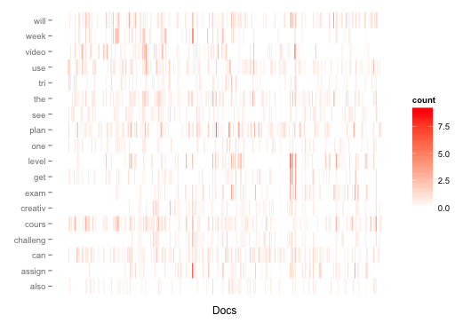

This would suggest 3 people have 300+ posts..

User e99fdd408b9870bcf17419d5e212c0a364a4dbd0 has 365

perhaps my query is messed up

File location: Aiplan_Forum/heat_of_freq_terms.png

Script location: R_workspace/heatmap.R

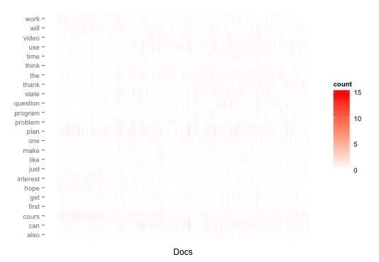

Topics Modelling

Comments: Too many documents doesn’t lend itself to heatmaps, perhaps comparable heatmaps of students X and Y.

Settings:

Topics 5:

topic.model$setAlphaOptimization(20, 50)

topic.model$train(200)

topic.model$maximize(10)

[1] "level exam score foundation awareness"

[2] "planning plan planner good level"

[3] "video week time challenge creative"

[4] "i'm interested computer hope learning"

[5] "state actions problem question search"

50:

Aiplan_Forum/topic50_posts.pdf

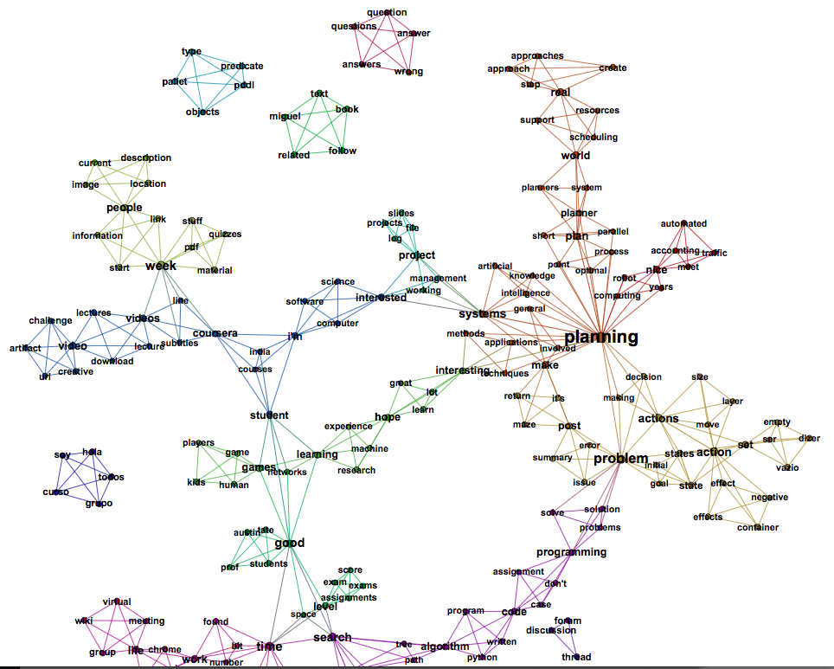

Full list:

[1] "todos hola curso soy grupo"

[2] "austin tate good students prof"

[3] "life meeting virtual group wiki"

[4] "nice meet automated accounting traffic"

[5] "programming assignment code case don't"

[6] "time work number found bit"

[7] "pddl predicate pallet type objects"

[8] "empty vazio set dizer ser"

[9] "planner plan planners system world"

[10] "thread forum https://class.coursera.org/aiplan discussion forum/thread?thread_id"

[11] "week quizzes material pdf stuff"

[12] "world support scheduling resources real"

[13] "intelligence artificial planning systems knowledge"

[14] "actions move action size layer"

[15] "search path algorithm graph tree"

[16] "work windows life running chrome"

[17] "hope lot interesting learn great"

[18] "level exam assignments score exams"

[19] "working management systems project interested"

[20] "question answer wrong questions answers"

[21] "state goal initial states problem"

[22] "planning robot nice years computing"

[23] "subtitles coursera line videos week"

[24] "time survey due date hard"

[25] "planning interesting applications techniques methods"

[26] "miss boat cann node missionaries"

[27] "book text follow related miguel"

[28] "game games kids human players"

[29] "video videos lectures lecture download"

[30] "good networks learning games student"

[31] "space time search level good"

[32] "image people location description current"

[33] "planner planning plan short parallel"

[34] "i'm computer interested science software"

[35] "program algorithm code python written"

[36] "plan planning point optimal process"

[37] "project file slides projects log"

[38] "planning actions problem making decision"

[39] "i'm coursera student india courses"

[40] "effects effect action container negative"

[41] "problem problems solution solve programming"

[42] "planning involved general make systems"

[43] "week start link people information"

[44] "error issue problem summary post"

[45] "set state actions states action"

[46] "step real approaches approach create"

[47] "nodes node search graph heuristic"

[48] "return make it's maze post"

[49] "learning hope machine research experience"

[50] "challenge creative video url artifact"